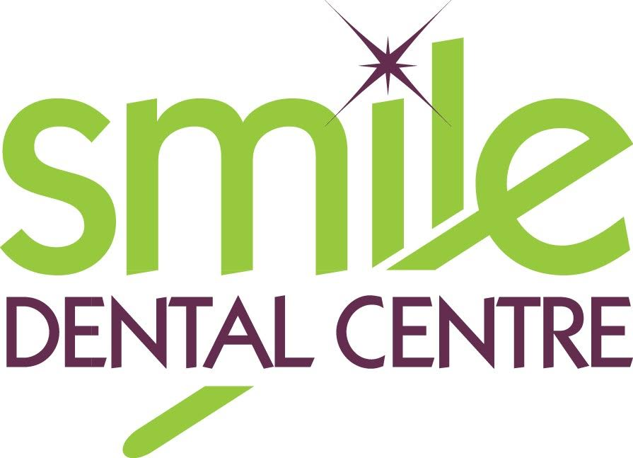
438 Whitmore Way, Basildon, Essex, SS14 2EZ
T: 01268-520-555, E: whitmorewaydentalcentre@gmail.com

WHAT TO EXPECT WHEN YOU VISIT US
To keep everyone safe in these difficult times, we have re-designed our service delivery to keep everyone as safe as possible, whilst still being able to deliver high quality dentistry.
BEFORE YOUR APPOINTMENT
- To make an appointment please phone us on 01268-520-555. We are operating a temporary closed door policy to maintain social distancing.
- If you have a smartphone / tablet / computer, we will ask to send you a link to complete the forms you would normally be given at reception. If you are not able to complete these, please bring a pen with you to the practice to fill out the paper forms. Let our team know if you are not able to complete these online, and they will pre-fill them in for you over the phone, to reduce time spent in the practice.
- We will phone to confirm you have not developed any Coronavirus symptoms on the day of your appointment. We will also ask you to make payment over the phone before your visit.
- Cash and cheques make infection control procedures difficult, so we would appreciate card payments where possible.
- When you attend, please avoid bringing any unnecessary bags / jackets where possible. These pose an infection control risk.
- Please prepare yourself at home to have freshly scrubbed teeth using your usual oral hygiene measures. Our patient toilet will be out of use, so please arrive prepared for this.
- We would be grateful if you could avoid bringing anybody else into our building. We will of course allow parents / translators and carers to enter where needed. Accompanying adults may be asked to wear a facemask.
- If it is raining, we will operate a socially distanced waiting room.
DURING YOUR APPOINTMENT
- When you arrive, the door will be locked so please wait in your car or outside the practice. Phone us to let us know you are here.
- When the practice has finished being decontaminated, and it is safe for you to enter our nurse will unlock the door dressed in Personal Protective Equipment.
- On entry, you will be asked to use hand sanitiser. If you are feverish, we may ask you to rebook your appointment for two weeks’ time. We ask that you avoid touching any surfaces in the practice.
- You will be directed straight into the surgery, to avoid use of the waiting room. The dentist and nurse will be dressed in Personal Protective Equipment again, so please do not be alarmed.
AFTER YOUR APPOINTMENT
- You will be offered hand sanitizer again, and our nurse will guide you back out of the practice. Any treatment plans will be emailed to you where possible. When you arrive home, please contact the practice at your convenience to arrange any follow up appointments needed.
- Thank you for bearing with us during these difficult times whilst we do our best to keep everyone as safe as possible.

We look forward to welcoming you soon!

